SDA Lab 3

22k-5195 Laiba Fatima

Task 1:

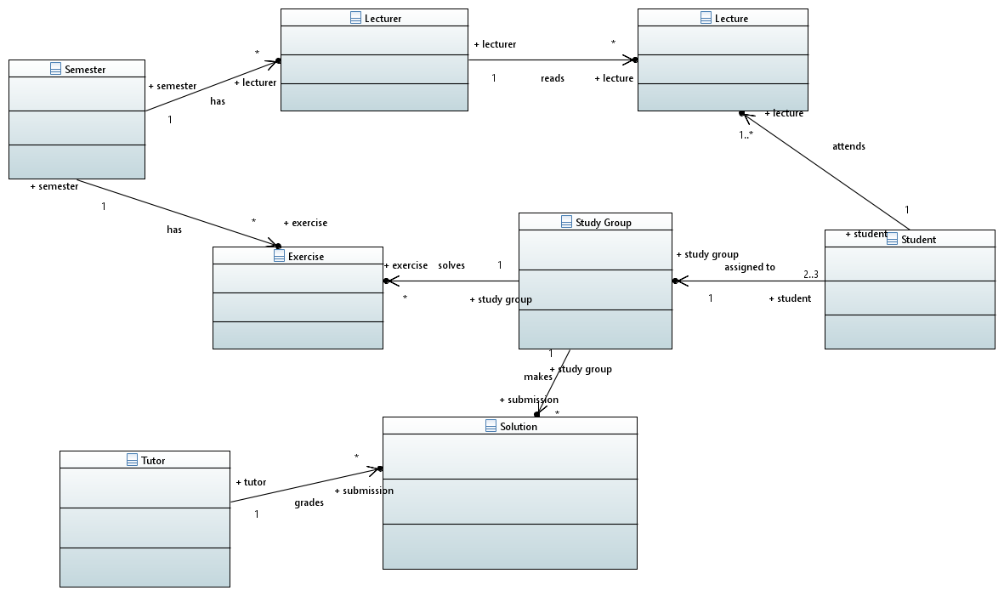

Task 2:

